Q1> Using HTML, CSS - Flex

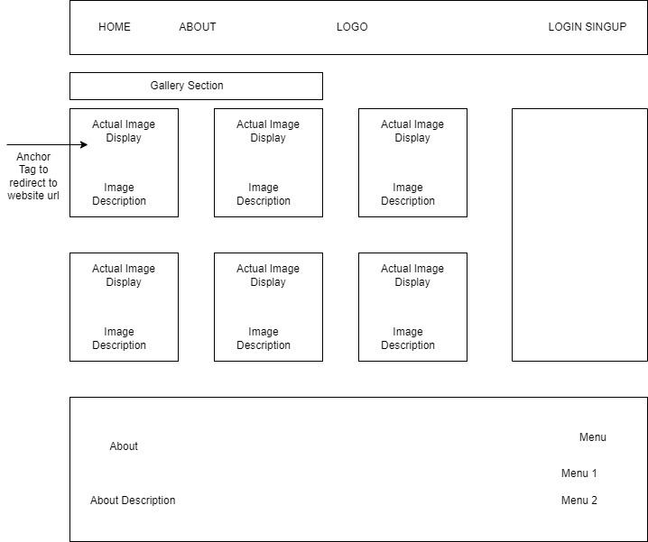

Q2> Using Html, CSS & JS

Q3> Using HTML, CSS, Jquery & JS

Post Clicking Tell Story, Please have content displayed as below using jQuery

Q4> React / Node /Express

Component =>

Header component , Login component , add user component, Add dialog open in same page after adding the information page redirecting to listing component.

1) Header should be only one

After login with demo details=>

edit the information also delete the information